**Exhibit A-1: JH Ranch Zone Change and Use Permit Project (Z-23-06 and UP-24-16)**

**APN: 023-190-510**

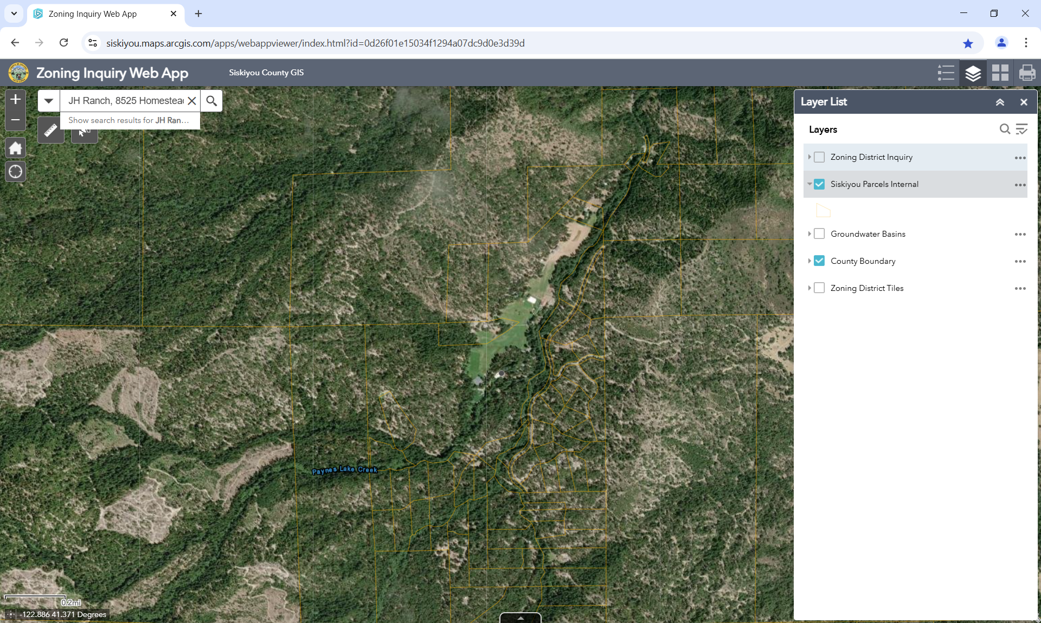

**~~PD~~**

**PD**